**235229119**

**Nivashini.J**

**Labsheet 14 neo4j**

**Question 1:**



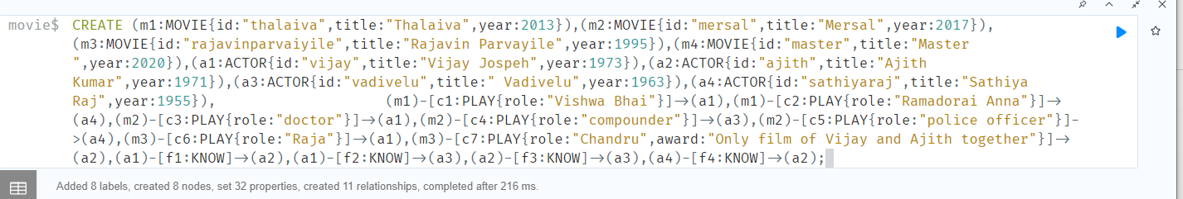

**Question 2:** 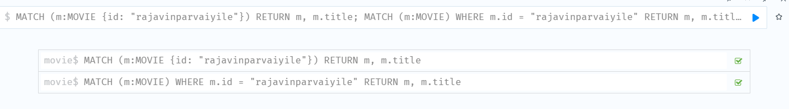

**Question 3:**

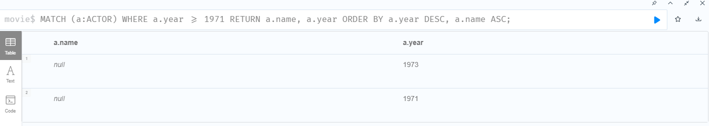

**Question 4:**

**Question 5:**

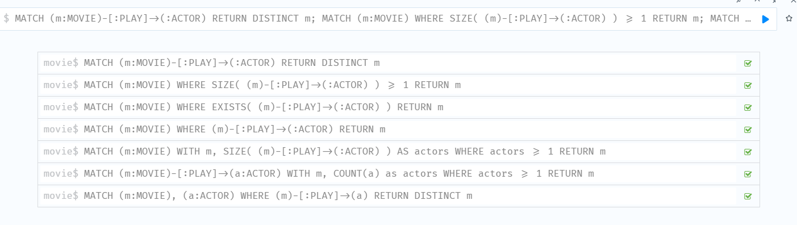

**Question 6:**

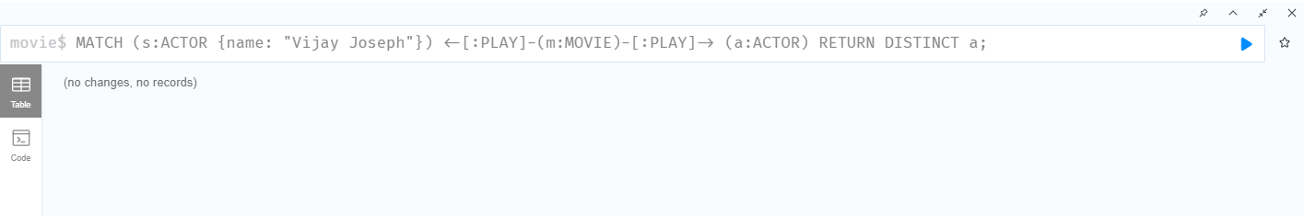

**Question 7:**

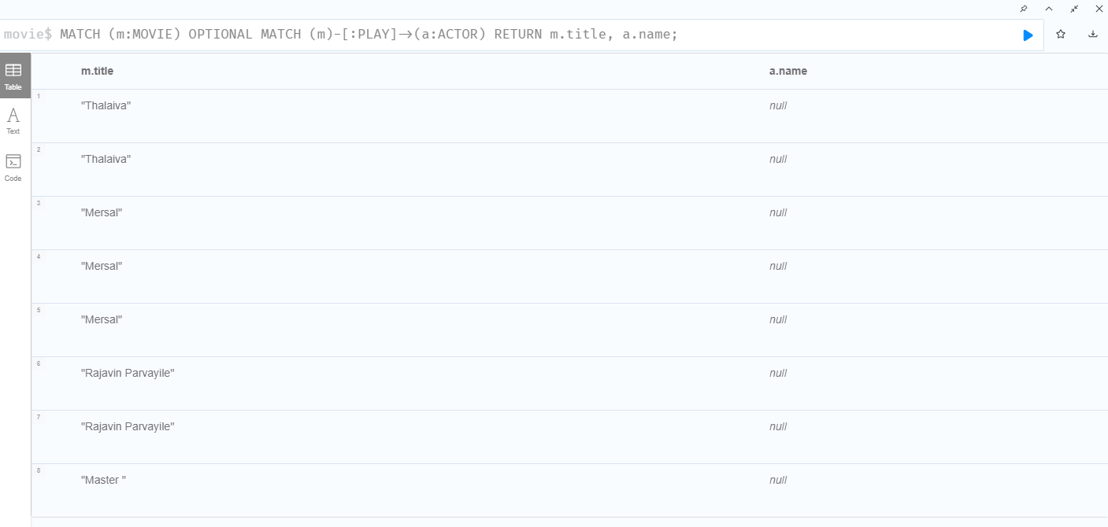

**Question 8:**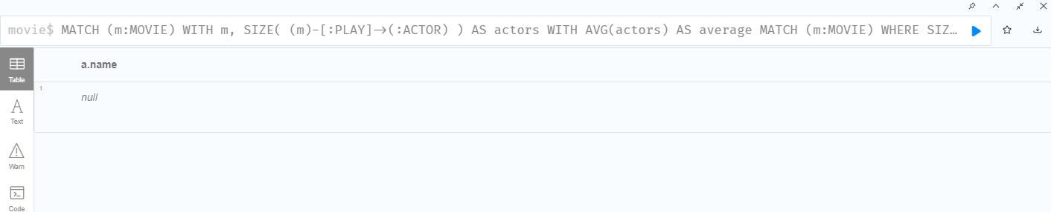

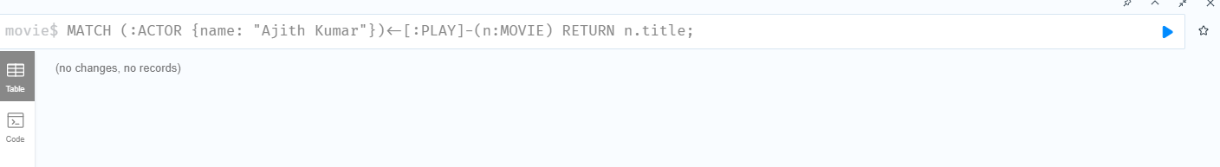

Question 9:

